# Packet Tracer - Configuring Initial Switch Settings

Topology:

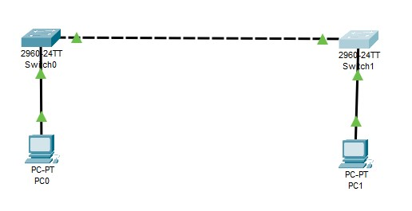 For Switch 1: For Switch 2:

Part 1: Verify the Default Switch Configuration Step 1: Enter privileged mode.

Step 2: Examine the current switch configuration.

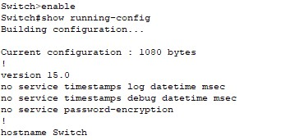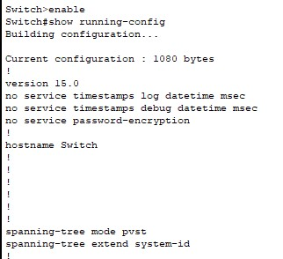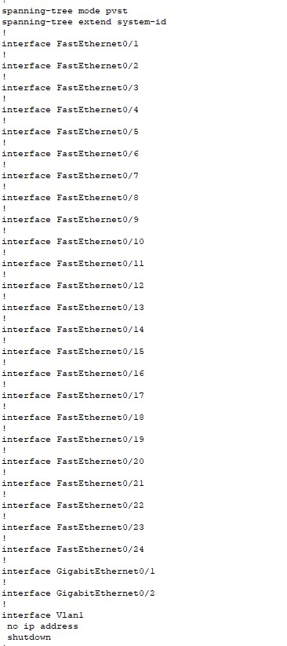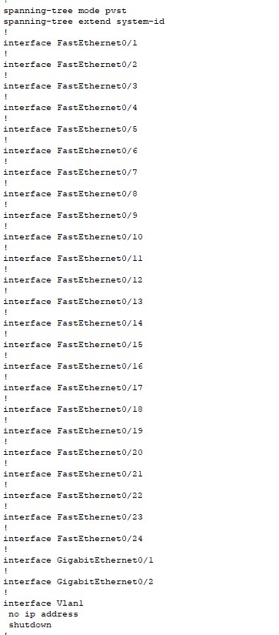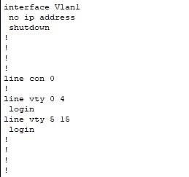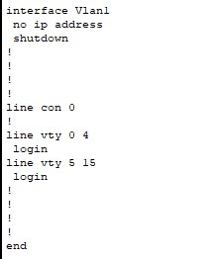

Part 2: Create a Basic Switch Configuration Step 1: Assign a name to a switch.

Step 2: Secure access to the console line.

Switch 1:

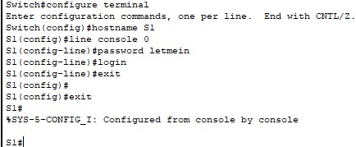

Switch 2:

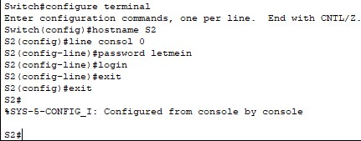

Step 3: Verify that console access is secured.

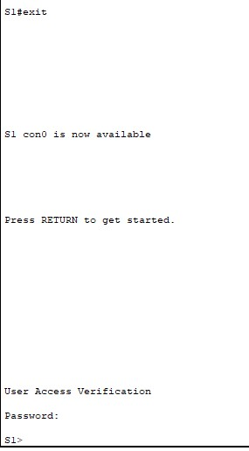 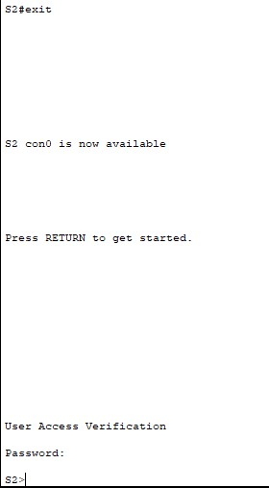

Step 4: Secure privileged mode access.

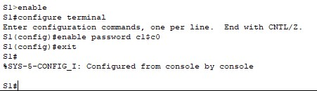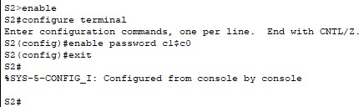

Step 5:Verify that privileged mode access is secure.

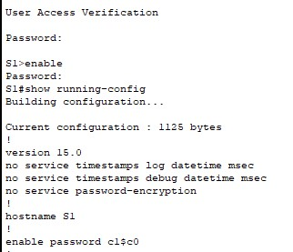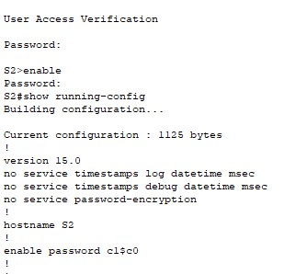

Step 6: Configure an encrypted password to secure access to privileged mode.

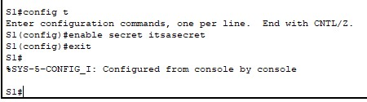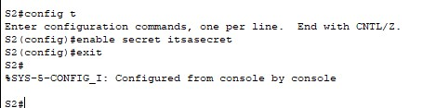

Step 7: Verify that the enable secret password is added to the configuration file.

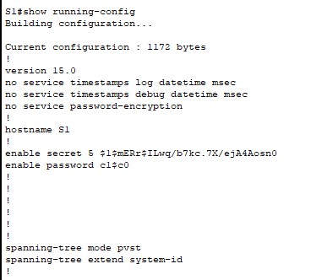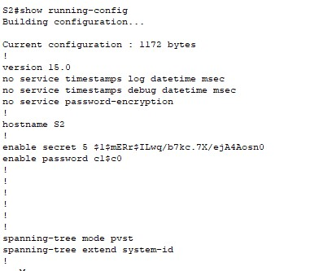

Part 3: Configure a MOTD Banner

Step 1:Configure a message of the day (MOTD) banner.

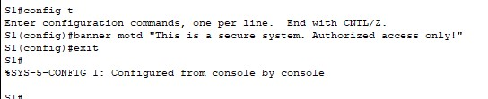

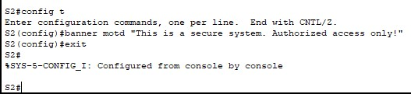

Part 4:Save Configuration Files to NVRAM

Step 1: Verify that the configuration is accurate using the show run command.

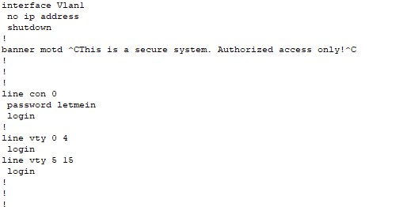

Step 2: Examine the startup configuration file.

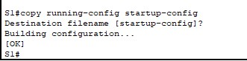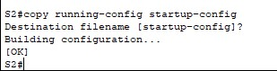

Step 3: Examine the startup configuration file.

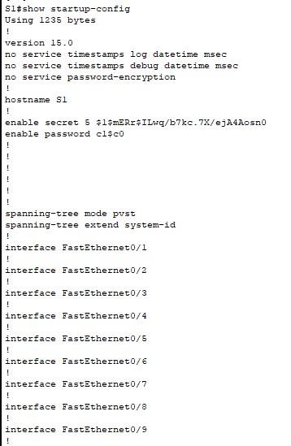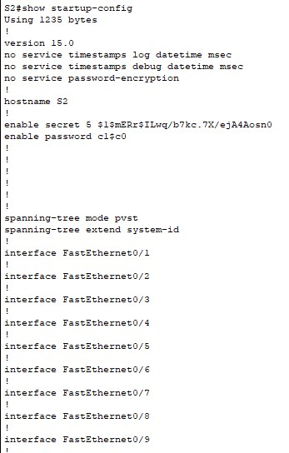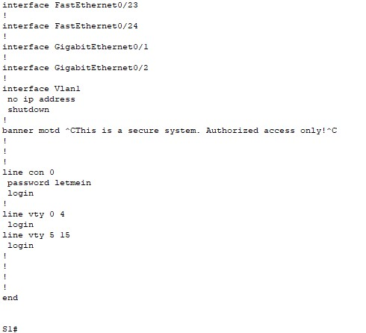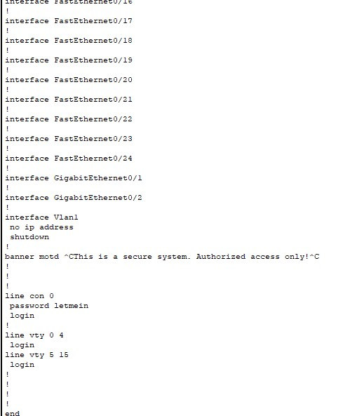

Part 5: Configure S2

Did along with the switch 1.

4. Check the connection with switch configuration using “ping” command: For switch 1:

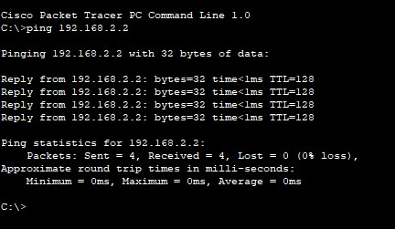

For switch 2:

